**HTML AND CSS**

**1.CUSTOMER REGISTRATION**

<!DOCTYPE html>

<html lang="en">

<head>

<meta charset="UTF-8">

<meta name="viewport" content="width=device-width, initial-scale=1.0">

<title>Customer registration</title>

<link rel="stylesheet" href="customer.css">

</head>

<body>

<form>

<div class="style">

<h2><center>CUSTOMER DETAILS </center></h2>

<div>

<label>CUSTOMER_NAME :</label>

<input type="text" ID="xxx" required>

</div>

<br>

<div>

<label>EMAIL </label>

<input type="text" ID="xxx" required>

</div>

<br>

<div>

<label>ADDRESS :</label>

<input type="text" ID="xxx" required>>

</div>

<br>

<div>

<label>CITY :</label>

<select>

<option>--SELECT--</option>

<option>Coimbatore</option>

<option>Cochin</option>

<option>Kurnool</option>

<option>Bengaluru</option>

</select>

</div>

<br>

<div>

<label>STATE :</label>

<select>

<option>--SELECT--</option>

<option>Tamilnadu</option>

<option>Kerala</option>

<option>Andra pradesh</option>

<option>Karnataka</option>

</select>

</div>

<br>

<div>

<label>PHONE :</label>

<input type="text" ID="xxx" required>

</div>

<br>

<div>

<input type="checkbox"><label>I agree to <a href="www.google.com">Terms and Condition</a></label>

</div>

<br>

<button TYPE="submit">REGISTER</button>

</div>

</form>

</style>

</body>

</html>

**CSS:**

.style{

background-color: rgba(169, 180, 13, 0.8);

width: 400px;

border-radius: 10px;

padding: 10px 30px 40px 40px;

top: 10%;

left: 30%;

position:absolute;

}

body{

background-image: url("grocery\ background.jpg");

background-size: cover;

background-repeat: no-repeat;

background-attachment: fixed;

}

#xxx{

border-radius: 5px;

color: black;

}

h2{

padding: 10px 60px;

}

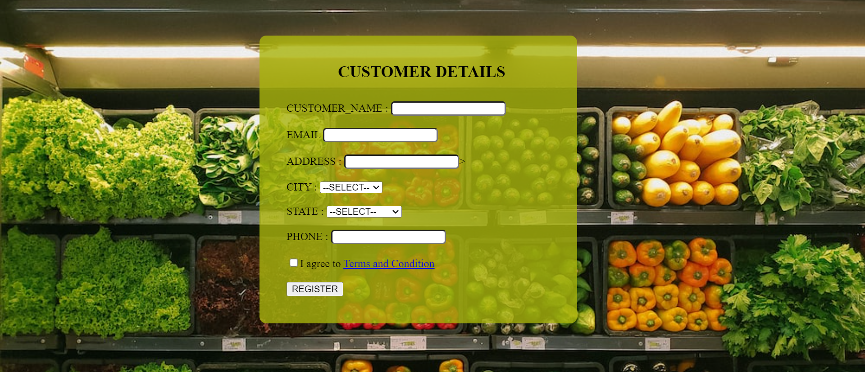

**2.PRODUCT FORM**

<!DOCTYPE html>

<html lang="en">

<head>

<meta charset="UTF-8">

<meta name="viewport" content="width=device-width, initial-scale=1.0">

<title>Prduct</title>

<link rel="stylesheet" href="product.css">

</head>

<body>

<form>

<div class="style">

<h2><center>PRODUCT DETAILS </center></h2>

<div>

<label>PRODUCT ID </label>

<input type="text" ID="xxx" required>

</div>

<br>

<div>

<label>PRODUCT NAME </label>

<input type="text" ID="xxx" required>

</div>

<br>

<div>

<label>CATEGORY </label>

<select>

<option>--SELECT--</option>

<option>Fruits</option>

<option>Diary</option>

<option>Bakery</option>

<option>Meat</option>

</select>

</div>

<br>

<div>

<label>DESCRIPTION</label>

<input type="text" ID="xxx" required>

</div>

<br>

<div>

<label>PRICE</label>

<input type="number" ID="xxx" required>

</div>

<br>

<div>

<label>STOCK QUANTITY</label>

<input type="number" ID="xxx" required>

</div>

<br>

<button TYPE="submit">NEXT</button>

</div>

</form>

</style>

</body>

</html>

**CSS**

.style{

background-color: rgba(169, 180, 13, 0.8);

width: 400px;

border-radius: 10px;

padding: 10px 30px 40px 40px;

top: 10%;

left: 30%;

position:absolute;

}

body{

background-image: url("grocery\ background.jpg");

background-size: cover;

background-repeat: no-repeat;

background-attachment: fixed;

}

#xxx{

border-radius: 5px;

color: black;

}

h2{

padding: 10px 60px;

}

**3.VENDOR**

<!DOCTYPE html>

<html lang="en">

<head>

<meta charset="UTF-8">

<meta name="viewport" content="width=device-width, initial-scale=1.0">

<title>Vendor Details</title>

<link rel="stylesheet" href="vendor.css">

</head>

<body>

<form>

<div class="style">

<header>

<h1><center>VENDOR DETAILS</center></h1>

</header>

<div>

<label>VENDOR NAME</label>

<input type="text" ID="xxx" required>

</div>

<br>

<div>

<label>CONTACT INFORMATION </label>

<input type="text" ID="xxx" required>

</div>

<br>

<div>

<label>ADDRESS</label>

<input type="text" ID="xxx" required>

</div>

<br>

<div>

<label>DELIVERY AREA </label>

<select>

<option>--SELECT--</option>

<option>City Area</option>

<option>Suburb</option>

<option>Rural Area</option>

</select>

</div>

<br>

<div>

<label>VENDOR RATING</label>

<input type="number" ID="xxx" required>

</div>

<footer>

<p>&copy; 2023 Vendor Management System</p>

</footer>

<br>

<button TYPE="submit">NEXT</button>

</div>

</form>

</style>

</body>

</html>

CSS

.style{

background-color: rgba(169, 180, 13, 0.8);

width: 400px;

border-radius: 10px;

padding: 10px 30px 40px 40px;

top: 10%;

left: 30%;

position:absolute;

}

body{

background-image: url("grocery background.jpg");

background-size: cover;

background-repeat: no-repeat;

background-attachment: fixed;

}

#xxx{

border-radius: 5px;

color: black;

}

h2{

padding: 10px 60px;

}

**4.ORDER**

<!DOCTYPE html>

<html lang="en">

<head>

<meta charset="UTF-8">

<meta name="viewport" content="width=device-width, initial-scale=1.0">

<title>Order</title>

<link rel="stylesheet" href="order.css">

</head>

<body>

<form>

<div class="style">

<h2><center>ORDER </center></h2>

<div>

<label>ORDER_ID: </label>

<input type="text" ID="xxx" required>

</div>

<br>

<div>

<label>CUSTOMER ID: </label>

<input type="text" ID="xxx" required>

</div>

<br>

<div>

<label>ORDER DATE</label>:</label>

<input type="date" ID="xxx" required>

</div>

<br>

<div>

<label>ORDER STATUS</label>

<select>

<option>--SELECT--</option>

<option>PENDING</option>

<option>DELIVERED</option>

</select>

</div>

<br>

<div>

<label>QUANTITY</label>

<input type="number" ID="xxx" required>

</div>

<br>

<div>

<label>UNIT PRICE</label>

<input type="number" ID="xxx" required>

</div>

<br>

<div>

<label>SUBTOTAL</label>

<input type="number" ID="xxx" required>

</div>

<br>

<button TYPE="submit">NEXT</button>

</div>

</form>

</body>

</html>

CSS

.style{

background-color: rgba(169, 179, 30, 0.8);

width: 400px;

border-radius: 10px;

padding: 10px 30px 40px 40px;

top: 10%;

left: 30%;

position:absolute;

}

body{

background-image: url("grocery background.jpg");

background-size: cover;

background-repeat: no-repeat;

background-attachment: fixed;

}

#xxx{

border-radius: 5px;

color: black;

}

h2{

padding: 10px 60px;

}

5.PAYMENT METHOD

<!DOCTYPE html>

<html lang="en">

<head>

<meta charset="UTF-8">

<meta name="viewport" content="width=device-width, initial-scale=1.0">

<title>Payment</title>

<link rel="stylesheet" href="payment.css">

</head>

<body>

<form>

<div class="style">

<h2><center>PAYMENT METHOD </center></h2>

<div>

<label>PAYMENT_METHOD_ID: </label>

<input type="text" ID="xxx" required>

</div>

<br>

<div>

<label>CUSTOMER ID: </label>

<input type="text" ID="xxx" required>

</div>

<br>

<div>

<label>PAYMENT METHOD</label>

<select>

<option>--SELECT--</option>

<option>Credit card</option>

<option>Debit card</option>

<option>Cash</option>

</select>

<br>

<button TYPE="submit">NEXT</button>

</div>

</form>

</body>

</html>

CSS

.style{

background-color: rgba(169, 179, 30, 0.8);

width: 400px;

border-radius: 10px;

padding: 10px 30px 40px 40px;

top: 10%;

left: 30%;

position:absolute;

}

body{

background-image: url("grocery background.jpg");

background-size: cover;

background-repeat: no-repeat;

background-attachment: fixed;

}

#xxx{

border-radius: 5px;

color: black;

}

h2{

padding: 10px 60px;

}

**6.REVIEW**

<!DOCTYPE html>

<html lang="en">

<head>

<meta charset="UTF-8">

<meta name="viewport" content="width=device-width, initial-scale=1.0">

<title>Review</title>

<link rel="stylesheet" href="review.css">

</head>

<body>

<form>

<div class="style">

<h2><center>REVIEWS </center></h2>

<div>

<label>REVIEW ID: </label>

<input type="text" ID="xxx" required>

</div>

<br>

<div>

<label>CUSTOMER ID: </label>

<input type="text" ID="xxx" required>

</div>

<br>

<div>

<label>RATING</label>

<select>

<option>--SELECT--</option>

<option>1</option>

<option>2</option>

<option>3</option>

<option>4</option>

<option>5</option>

</select>

</div>

<br>

<div>

<label>REVIEWS</label>

<input type="text" ID="xxx" required >

</div>

<br>

<button TYPE="submit">NEXT</button>

</div>

</form>

</body>

</html>

**CSS**

.style{

background-color: rgba(169, 180, 13, 0.8);

width: 400px;

border-radius: 10px;

padding: 10px 30px 40px 40px;

top: 10%;

left: 30%;

position:absolute;

}

body{

background-image: url("grocery\ background.jpg");

background-size: cover;

background-repeat: no-repeat;

background-attachment: fixed;

}

#xxx{

border-radius: 5px;

color: black;

}

h2{

padding: 10px 60px;

}

**7.DELIVERY STATUS**

<!DOCTYPE html>

<html lang="en">

<head>

<meta charset="UTF-8">

<meta name="viewport" content="width=device-width, initial-scale=1.0">

<title>DELIVERY TRACKING</title>

<link rel="stylesheet" href="deliverystatus.css">

</head>

<body>

<form>

<div class="style">

<h2><center>TRACK DELIVERY</center></h2>

<div>

<label>ORDER ID: </label>

<input type="text" ID="xxx" required>

</div>

<br>

<div>

<label>CUSTOMER ID: </label>

<input type="text" ID="xxx" required>

</div>

<br>

<div>

<label>STATUS</label>

<select>

<option>--SELECT--</option>

<option>Pending</option>

<option>Delivered</option>

<option>En route</option>

</select>

</div>

<br>

<button TYPE="submit">NEXT</button>

</div>

</form>

</body>

</html>

**CSS**

.style{

background-color: rgba(169, 179, 30, 0.8);

width: 400px;

border-radius: 10px;

padding: 10px 30px 40px 40px;

top: 10%;

left: 30%;

position:absolute;

}

body{

background-image: url("grocery background.jpg");

background-size: cover;

background-repeat: no-repeat;

background-attachment: fixed;

}

#xxx{

border-radius: 5px;

color: black;

}

h2{

padding: 10px 60px;

}

**8.PROMOTION**

<!DOCTYPE html>

<html lang="en">

<head>

<meta charset="UTF-8">

<meta name="viewport" content="width=device-width, initial-scale=1.0">

<title>PROMO</title>

<link rel="stylesheet" href="promotion.css">

</head>

<body>

<form>

<div class="style">

<h2><center>PROMO </center></h2>

<div>

<label>PROMOTION ID </label>

<input type="text" ID="xxx" required>

</div>

<br>

<div>

<label>PRODUCT NAME </label>

<input type="text" ID="xxx" required>

</div>

<br>

<div>

<label>PRODUCT ID </label>

<input type="text" ID="xxx" required>

</div>

<br>

<div>

<label>DISCOUNT PERCENTAGE</label>

<input type="number" ID="xxx" required>

</div>

<br>

<div>

<label>START DATE</label>

<input type="date" ID="xxx" required>

</div>

<br>

<div>

<label>END DATE</label>

<input type="date" ID="xxx" required>

</div>

<br>

<button TYPE="submit">NEXT</button>

</div>

</form>

</style>

</body>

</html>

**CSS**

.style{

background-color: rgba(169, 180, 13, 0.8);

width: 400px;

border-radius: 10px;

padding: 10px 30px 40px 40px;

top: 10%;

left: 30%;

position:absolute;

}

body{

background-image: url("grocery\ background.jpg");

background-size: cover;

background-repeat: no-repeat;

background-attachment: fixed;

}

#xxx{

border-radius: 5px;

color: black;

}

h2{

padding: 10px 60px;

}